1. What is searching? Compare binary search and sequential search.

“Searching is an operation which finds the location of a given element in a list”

The search is said to be successful or unsuccessful depending on whether the element that is to be searched is found or not.
Binary search definition: Search a sorted array by repeatedly dividing the search interval in half. Begin with an interval covering the whole array. If the value of the search key is less than the item in the middle of the interval, narrow the interval to the lower half. Otherwise narrow it to the upper half. Repeatedly check until the value is found or the interval is empty.
Linear search definition: Search an array or list by checking items one at a time. Also known as sequential search

Consider the following set of elements:

1, 2, 3, 9, 11, 13, 17, 25, 57, 90

Suppose we want to search 25 in the above set of numbers. Following Table shows number of comparisons required in both the methods.

Method | Number Of Comparisons
Linear search | 8
Binary search | 3

Comparison between linear search and binary search.

The table clearly shows that how fast a binary search algorithm works. The advantage of the binary search method is that, in each iteration it reduces the number of elements to be searched from n to n/2. On the other hand, linear search method checks sequentially for every element, which makes it inefficient. The disadvantage of binary search is that it works only on sorted lists. So when searching is to be performed on unsorted list then linear search is the only option.

2. Explain Binary search technique.

Binary search method is very fast and efficient. This method requires that the list of elements be in sorted order.
In this method, to search an element we compare it with the element present at the center of the list. If 1t matches then the search is successful. Otherwise, the list is divided into two halves: one from 0th element to the center element (first half), and another from center element to the last element (second half). As a result, all the elements in first half are smaller than the center element, whereas, all the elements in second half are greater than the center element.
The searching will now proceed in either of the two halves depending upon whether the element is greater or smaller than the center element. If the element is smaller than the center element then the searching will be done in the first half, otherwise in the second half. Same process of comparing the required element with the center element and if not found then dividing the elements into two halves is repeated for the first half or second half. This procedure is repeated till the element is found or the division of half parts gives one element. Let us understand this with the help of following Figure
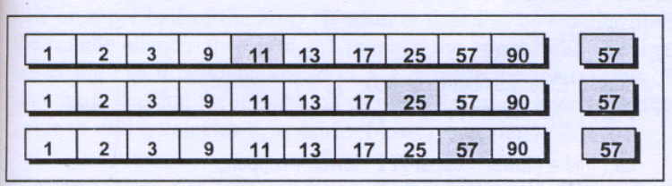

Suppose an array arr consists of 10 sorted numbers and 57 is element that is to be searched. The binary search method when applied to this array works as follows:

(a) 57 is compared with the element present at the center of the list (i.e. 11). Since 57 is greater than 11, the searching is restricted only to the second half of the array.

(b) Now 57 is compared .with the center element of the second half of array (i.e. 25). Here again 57 is greater than 25 so the searching now proceed in the elements present between the 25 and the last element 90.

(c) This process is repeated till 57 is found or no further division of sub-array is possible. The maximum number of comparisons in binary search is limited to log ₂ n.

3. Write an algorithm/program for binary search.

- Algorithm for binary search.
1) Start
2) Accept n different items. Let this be in array arr.
3) set lower = 0
upper = n – 1
4) Accept the key to be searched in the n different items. Let it be k.
5) Repeat steps (a) to (c) as long as (lower <= upper)
a) mid = ( lower + upper ) / 2
b) if ( k = arr[mid] )
print “item is in mid position “
goto step 7.
c) if (arr[mid] > k )
upper = mid – 1
otherwise
lower = mid + 1
6) print “item could not found in the list of items.
7) Stop.

- Program for binary search.

Following program implements binary search algorithm for a sorted array.

void main( )
{
int arr[10] = { 1, 2, 3, 9, 11, 13,17, 25, 57, 90} ;
int mid, lower=0 , upper=9, num, flag=1;

clrscr( ) ;

printf( "Enter number to search:" ) ;
scanf( "%d",&num) ;

for ( mid= ( lower + upper)/ 2 ; lower<=upper; mid=( lower + upper)/ 2 )
{
if ( arr[mid] == num)
{
printf( "The number is at position %d in the array.", mid) ;
flag=0 ;
break;
}

if( arr[mid] > num )
upper = mid - 1;
else
lower = mid - 1;

}

if ( flag==1)
printf( "Element is not present in the array.") ;

getch( ) ;

}

3. Explain Bubble Sort

In bubble sort, each element is compared with its adjacent element. If the first element is larger than the second one, then the positions of the elements are interchanged, otherwise it is not changed. Then next element is compared with its adjacent element and the same process is repeated for all the elements in the array until we get a sorted array.
Let A be a linear array of n numbers. Sorting of A means rearranging the elements of A so that they are in order. Here we are dealing with ascending order. i.e., A[1] < A[2] < A[3] < ...... A[n].
The following figures will depict the various steps (or PASS) involved in the sorting of an array of 5 elements.The elements of an array A to be sorted are: 42, 33, 23, 74, 44

First Pass :
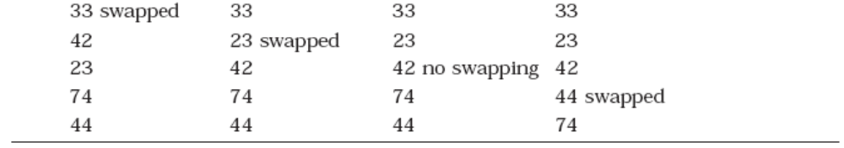

Second Pass :
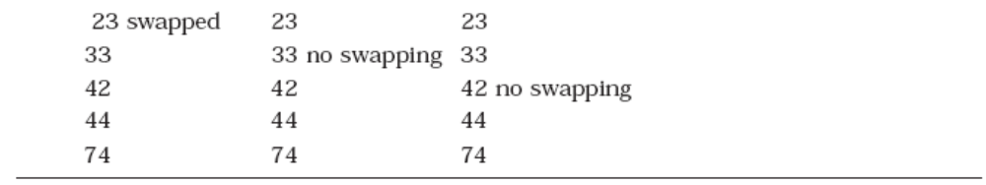

Third Pass :
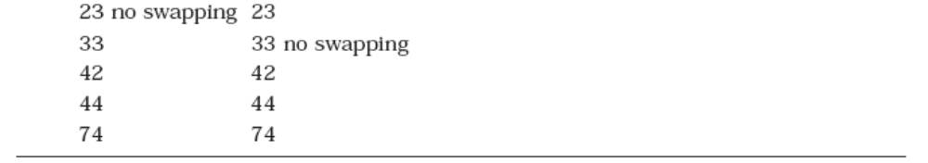
Fourth Pass :
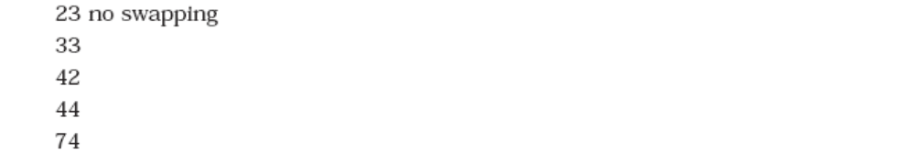
Thus the sorted array is 23, 33, 42, 44, 74.

- ALGORITHM
Let A be a linear array of n numbers. Swap is a temporary variable for swapping (or interchange) the position of the numbers.

- Start
- Input n numbers of an array A
- Initialise i = 0.
- Initialise j=0.
- Repeat through step 6 and 7 if (j < n – i – 1) otherwise go to step 8.
- If (A[j] > A[j + 1])
  - Swap = A[j]
  - A[j] = A[j + 1]
  - A[j + 1] = Swap
- Increase j by 1.
- Increase i by 1
- If (i < n) then goto step 4 otherwise go to step 10.
- Display the sorted numbers of array A
- Exit

- Program to implement bubble sort using arrays

#define MAX 20
void main()
{
int arr[MAX], i, j, k, temp, n,;
clrscr();
printf (“\nEnter the number of elements : ”);
scanf (“%d”,&n);
for (i = 0; i < n; i++)
{
printf (“E\nnter element %d : ”,i+1);
scanf (“%d”,&arr[i]);
}
printf (“\nUnsorted list is :\n”);
for (i = 0; i < n; i++)
printf (“%d ”, arr[i]);
printf (“\n”);
/* Bubble sort*/
for (i = 0; i < n–1 ; i++)
{
for (j = 0; j <n–1–i; j++)
{
if (arr[j] > arr[j+1])
{
temp = arr[j];
arr[j] = arr[j+1];
arr[j+1] = temp;
}
}
}
printf(“\nSorted list is :\n”);
for (i = 0; i < n; i++)
printf(“%d ”, arr[i]);
getch();
}

4. Explain selection sort and Write an algorithm/program for selection sort.
Selection sort algorithm finds the smallest element of the array and interchanges it with the element in the first position of the array. Then it finds the second smallest element from the remaining elements in the array and places it in the second position of the array and so on.
Following figure is generated during the iterations of the algorithm to sort 5 numbers
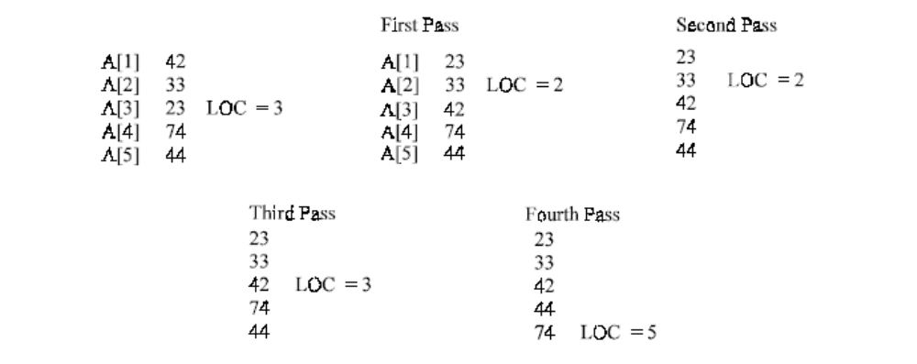
42, 33, 23, 74, 44 :

- Program for selection sort.

#include <stdio.h>
void main( )
{
int arr[ 5 ] = { 25, 17, 31, 13, 2 } ;
int i, j, temp ;

clrscr( ) ;

printf ( "Selection sort.\n" ) ;
printf ( "\nArray before sorting:\n") ;

for ( i = 0 ; i <= 4 ; i++ )
printf ( "%d\t", arr[ i ] ) ;

for ( i = 0 ; i <= 3 ; i++ )
{
for ( j = i + 1 ; j <= 4 ; j++ )
{
if ( arr[ i ] > arr[ j ] )
{
temp = arr[ i ] ;
arr[ i ] = arr[ j ] ;
arr[ j ] = temp ;
}
}
}

printf ( "\n\nArray after sorting:\n") ;

for ( i = 0 ; i <= 4 ; i++ )
printf ( "%d\t", arr[ i ] ) ;

getch( ) ;
}

- Algorithm for selection sort.
1) Start
2) Accept n different items. Let this be in array arr.
3) set i = 0
4) set j = i + 1
5) Compare i^{th} element of array arr with j^{th} element of array arr
If arr[ i ] is greater then arr[ j ] then set i^{th} element to j^{th} element and j^{th} to i^{th}
6) Increment j by 1.
7) Repeat steps (4) to (6) until ( j < n ) otherwise go to step 8
8) Increment i by 1.
9) Go to step (4) if ( i < n - 1 )
11) Now the element will be in the sorted order. Print them.
12) Stop.

4. Write an algorithm/program for insertion sort.
- Program for insertion sort.
#include <conio.h>

void main( )
{
int arr[ 5 ] = { 25, 17, 31, 13, 2 } ;
int i, j, k, temp ;

clrscr( ) ;

printf ( "Insertion sort.\n" ) ;
printf ( "\nArray before sorting:\n") ;

for ( i = 0 ; i <= 4 ; i++ )
printf ( "%d\t", arr[ i ] ) ;

for ( i = 1 ; i <= 4 ; i++ )
{
for ( j = 0 ; j < i ; j++ )
{
if ( arr[ j ] > arr[ i ] )
{
temp = arr[ j ] ;
arr[ j ] = arr[ i ] ;

for ( k = i ; k > j ; k-- )
arr[ k ] = arr[ k – 1] ;

arr[ k + 1] = temp ;
}
}
}

printf ( "\n\nArray after sorting:\n") ;

for ( i = 0 ; i <= 4 ; i++ )
printf ( "%d\t", arr[ i ] ) ;

getch( ) ;
}

- Algorithm for insertion sort.

1) Start
2) Accept n different items. Let this be in array arr.
3) set i = 1
4) set j = 0
5) Compare j^{th} element of array arr with i^{th} element of array arr
6) If arr[ j ] is greater then arr[ i ] then set temp=arr[ j] and set arr[ j] = arr[ j]
7) set k = i
8) set arr[ k] =arr[ k -1]
9) Decrement k by 1
10) Repeat steps (8) to (9) until ( k > j ) otherwise go to step12
11) set arr[k + 1] = temp
12) Increment j by 1.
13) Repeat steps (4) to (7) until ( j < n ) otherwise go to step14
14) Increment i by 1.
15) Go to step (4) if ( i < n - 1 )
16) Now the element will be in the sorted order. Print them.
17) Stop.

5. Explain quick sort. and Write an algorithm/program for Quick sort.

- Program for Quick sort.

#include <stdio.h>

void main()

{
int a[20], i, n=0;
void quick_sort();
clrscr();

printf("\n How many numbers do you want to sort====>");
scanf("%d",&n);

for (i = 0; i < n; i++)
{
printf("Enter a number %d ====>",i+1);
scanf("%d",&a[i]);
}

printf("\n Unsorted list is as follows \n");

for (i = 0; i < n; i++)
{
printf("%d\t",a[i]);
}

quick_sort(a, 0, n-1);

printf("\n Sorted list as follows\n");

for (i = 0; i < n; i++)
{
printf("%d\t", a[i]);
}
}

void quick_sort(int arr[ ], int first, int last)
{

int temp, low, high, p;

low = first;
high = last;
p = arr[(first + last) / 2];

do {
while (arr[low] < p)
low++;

while (arr[high] > p)
high--;

if (low <= high)
{
temp = arr[low];
arr[low++] = arr[high];
arr[high--] = temp;
}
} while (low <= high);

if (first < high)
quick_sort(arr, first, high);

if (low < last)
quick_sort(arr, low, last);

}

- Algorithm for quick sort.

1) Start
2) Accept n different items. Let this be in array arr.
3) set i = 1
4) set j = 0
5) Compare j^{th} element of array arr with i^{th} element of array arr
6) If arr[ j ] is greater then arr[ i ] then set temp=arr[ j] and set arr[ j] = arr[ j]
7 set k = i
8) set arr[ k] =arr[ k -1]
9) Decrement k by 1
10) Repeat steps (8) to (9) until ( k > j ) otherwise go to step12
11) set arr[k + 1] = temp
12) Increment j by 1.
13) Repeat steps (4) to (7) until ( j < n ) otherwise go to step14
14) Increment i by 1.
15) Go to step (4) if ( i < n - 1 )
16) Now the element will be in the sorted order. Print them.
17) Stop.

6. Explain quick sort.
Quick sort is a very efficient sorting algorithm invented by C.A.R. Hoare. It has two phases:
- the partition phase and
- the sort phase.
Quick sort is a divide-and-conquer style algorithm. A divide-and-conquer algorithm solves a given problem by splitting it into two or smaller sub problems, recursively solving each of the sub problems, and then combining the solutions to the smaller problems to obtain a solution to the original one.

To sort the sequence , S={s1,s2,s3,…..,s_{n}}
quicksort performs the following steps:
- Select one of the elements of S. The selected element, p, is called the pivot .
- Remove p from S and then partition the remaining elements of S into two distinct sequences, L and G, such that every element in L is less than or equal to the pivot and every element in G is greater than or equal to the pivot. In general, both L and G are unsorted.
- Rearrange the elements of the sequence as follows:
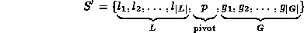

Notice that the pivot is now in the position in which it belongs in the sorted sequence, since all the elements to the left of the pivot are less than or equal to the pivot and all the elements to the right are greater than or equal to it.
- Recursively quick sort the unsorted sequences L and G.
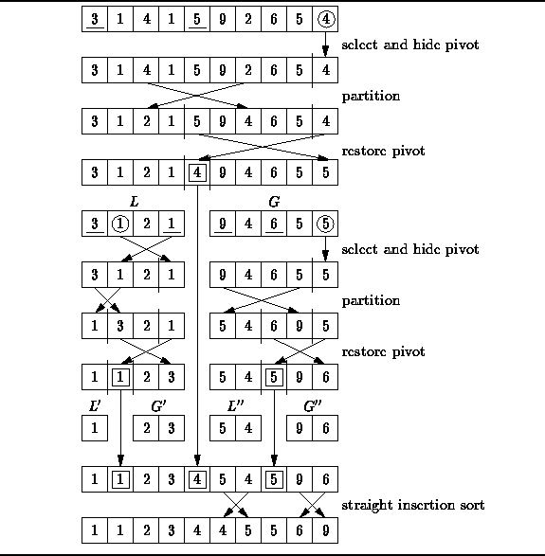
Following Figure illustrates the detailed operation of quick sort as it sorts the array a[10] = {3, 1, 4, 1, 5, 9, 2, 6, 5, 4 }. To begin the sort, we select a pivot. In this example, the value 4 in the last array position is chosen. Next, the remaining elements are partitioned into two sequences, one which contains values less than or equal to 4 (L={3, 1, 2, 1}) and one which contains values greater than or equal to 4 ( G={5, 9, 4, 6, 5}).

``Quick'' Sorting
After the partitioning, the pivot is inserted between the two sequences. This is called restoring the pivot. To restore the pivot, we simply exchange it with the first element of G. Notice that the 4 is in its correct position in the sorted sequence and it is not considered any further.
Now the quick sort algorithm calls itself recursively, first to sort the sequence L={3, 1, 2, 1}; second to sort the sequence G={5, 9, 4, 6, 5}. The quick sort of L selects 1 as the pivot, and creates the two subsequences L’= {1} and G’= {2, 3}. Similarly, the quick sort of G uses 5 as the pivot and creates the two subsequences L’’= {5, 4} and G’’= {9, 6}.
At this point in the example the recursion has been stopped. It turns out that to keep the code simple, quick sort algorithms usually stop the recursion when the length of a subsequence falls below a critical value called the cut-off. In this example, the cut-off is two (i.e., a subsequence of two or fewer elements is not sorted). This means that when the algorithm terminates, the sequence is not yet sorted. However as the sequence is almost sorted. In fact, every element is guaranteed to be less than two positions away from its final resting place. We can complete the sorting of the sequence by using a straight insertion sort.
7. Explain shell sort.
The shell sort is named after its developer Donald shell. The sort technique works by comparing the list elements that are separated by a specific distance i.e. a gap until the elements compared with the current gap are in order. Two then divides gap and the process continues. When the gap is reached 0 and no changes are possible, the list is sorted.
For example, consider a list which contains the elements: 11, 88, 22, 77, 33, 66, 44, 55.

Iteration : 1
size = 8
gap = size/2 = 8/2 = 4
and initial value of swap is 0

11 |  | 11 |  | 11 |  | 11 |  | 11
88 |  | 88 |  | 66 |  | 66 |  | 66
22 |  | 22 |  | 22 |  | 22 |  | 22
77 |  | 77 |  | 77 |  | 77 |  | 55
33 |  | 33 |  | 33 |  | 33 |  | 33
66 |  | 66 |  | 88 |  | 88 |  | 88
44 |  | 44 |  | 44 |  | 44 |  | 44
55 |  | 55 |  | 55 |  | 55 |  | 77

After completion of the first iteration the value of the swap becomes 1 hence further execution with gap = 4 is possible. Now after second iteration, the value of swap is 0 so further execution is not possible.

Iteration : 2
gap = gap/2 = 4/2 = 2
and initial value of swap is 0

11 |  | 11 |  | 11 |  | 11 |  | 11 |  | 11 |  | 11
66 |  | 66 |  | 55 |  | 55 |  | 55 |  | 55 |  | 55
22 |  | 22 |  | 22 |  | 22 |  | 22 |  | 22 |  | 22
55 |  | 55 |  | 66 |  | 66 |  | 66 |  | 66 |  | 66
33 |  | 33 |  | 33 |  | 33 |  | 33 |  | 33 |  | 33
88 |  | 88 |  | 88 |  | 88 |  | 88 |  | 88 |  | 77
44 |  | 44 |  | 44 |  | 44 |  | 44 |  | 44 |  | 44
77 |  | 77 |  | 77 |  | 77 |  | 77 |  | 77 |  | 88

After completion of the second iteration the value of the swap becomes 1 hence further execution with gap = 2 is possible. Now after second iteration, the value of swap is 0 so further execution is not possible.

Iteration : 3
gap = gap/2 = 2/2 = 1
and initial value of swap is 0

With the help of gap = 1 execution starts, after completion of first iteration we get value of swap = 1, hence further execution with gap =1 is possible. Execution once again resume and after completion of execution the value of swap remain 1, once again the same process is repeated and after third execution the value of swap becomes 0 and now further execution is not possible.
11 |  | 11 |  | 11 |  | 11 |  | 11 |  | 11 |  | 11
55 |  | 55 |  | 22 |  | 22 |  | 22 |  | 22 |  | 22
22 |  | 22 |  | 55 |  | 55 |  | 55 |  | 55 |  | 55
66 |  | 66 |  | 66 |  | 66 |  | 33 |  | 33 |  | 33
33 |  | 33 |  | 33 |  | 33 |  | 66 |  | 66 |  | 66
77 |  | 77 |  | 77 |  | 77 |  | 77 |  | 77 |  | 44
44 |  | 44 |  | 44 |  | 44 |  | 44 |  | 44 |  | 77
88 |  | 88 |  | 88 |  | 88 |  | 88 |  | 88 |  | 88

11 |  | 11 |  | 11 |  | 11 |  | 11 |  | 11 |  | 11
22 |  | 22 |  | 22 |  | 22 |  | 22 |  | 22 |  | 22
55 |  | 55 |  | 55 |  | 33 |  | 33 |  | 33 |  | 33
33 |  | 33 |  | 33 |  | 55 |  | 55 |  | 55 |  | 55
66 |  | 66 |  | 66 |  | 66 |  | 66 |  | 44 |  | 44
44 |  | 44 |  | 44 |  | 44 |  | 44 |  | 66 |  | 66
77 |  | 77 |  | 77 |  | 77 |  | 77 |  | 77 |  | 77
88 |  | 88 |  | 88 |  | 88 |  | 88 |  | 88 |  | 88

11 |  | 11 |  | 11 |  | 11 |  | 11 |  | 11 |  | 11
22 |  | 22 |  | 22 |  | 22 |  | 22 |  | 22 |  | 22
33 |  | 33 |  | 33 |  | 33 |  | 33 |  | 33 |  | 33
55 |  | 55 |  | 55 |  | 55 |  | 44 |  | 44 |  | 44
44 |  | 44 |  | 44 |  | 44 |  | 55 |  | 55 |  | 55
66 |  | 66 |  | 66 |  | 66 |  | 66 |  | 66 |  | 66
77 |  | 77 |  | 77 |  | 77 |  | 77 |  | 77 |  | 77
88 |  | 88 |  | 88 |  | 88 |  | 88 |  | 88 |  | 88

- Algorithm of shell sort :-

1) Start
2) Accept n different items. Let this be in array arr.
3) [initialize] gap = n / 2
4) Repeat through step 8 while gap is not equal to zero
5) swap = 0
6) Repeat through step 8 while swap is not equal to zero
7) Repeat through step 8 for i= 0, 1, 2, 3,……i < (n – gap)
8) if (arr[ i ] > arr [ i + gap ] )
( i ) temp = arr [ i ]
(ii) arr [ i ] = arr [ i + gap]
(iii) arr [ i + gap] = temp
(iv) swap=1
9) ( i ) if swap = 1 then go to step 4 otherwise go to ( ii )
( ii ) if gap > 0 then go to step 2 other wise go to (iii)
(iii) if swap=0 and gap = 0 then go to step 10
10) print the array elements which are in sorted order
11) Stop

- Program of shell sort :-

#include <stdio.h>
void main()
{
int values[50], i;
void shell_sort();

for (i = 0; i < 10; i++)
{
printf(" Enter a number===>");
scanf("%d",&values[i]);
}
printf("\n Unsorted list is as follows \n");

for (i = 0; i < 10; i++)
{
printf("%d\t",values[i]);
}
shell_sort(values, 10);

printf("\n Sorted list is as follows \n");

for (i = 0; i < 10; i++)
printf("%d ", values[i]);
getch();
}

void shell_sort(int array[], int size)
{
int temp, gap, i, exchange_occurred;
gap = size / 2;
do {
do {
exchange_occurred = 0;

for (i = 0; i < size - gap; i++)
if (array[i] > array[i + gap])
{
temp = array[i];
array[i] = array[i + gap];
array[i + gap] = temp;
exchange_occurred = 1;
}
} while (exchange_occurred);
} while (gap = gap / 2);
}

8. Explain radix sort.

Radix sort or bucket sort is a method that can be used to sort a list of numbers by its base. If we want to sort list of English words, where radix or base is 26, then 26 buckets is used to sort the words.
To sort an array of decimal numbers, where the radix or base is 10, we need 10 buckets and can be numbered as 0, 1, 2, 3, 4, 5, 6, 7, 8, 9. Number of passes required to have a sorted array depends upon the number of digits in the largest element. To illustrate the radix sort, consider the following array with 7 elements : 42, 133, 7, 23, 74, 670, 49
In this array the biggest element is 670 and the number of digit is 3. So 3 passes are required to sort the array. Read the element(s) and compare the first position (2 is in first position of 42) digit with the digit of the bucket and place it.

First Pass :

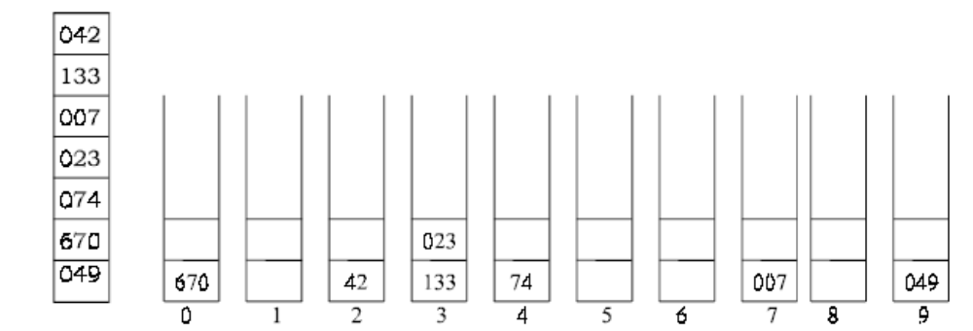

Now read the elements from left to right and bottom to top of the buckets and place it in array for the next pass. Read the array element and compare the second position (4 is in second position of the element 042) digit with the number of the bucket and place it.

Second Pass :

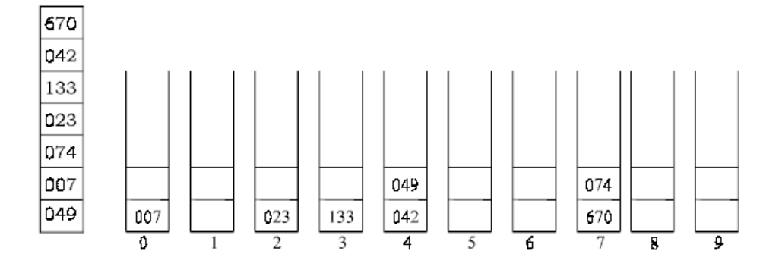

Again read the element from left to right and from bottom to top to get an array for the third pass. (0 is in the third position of 042) Compare the third position digit in each element with the bucket digit and place it wherever it matches.

Third Pass :
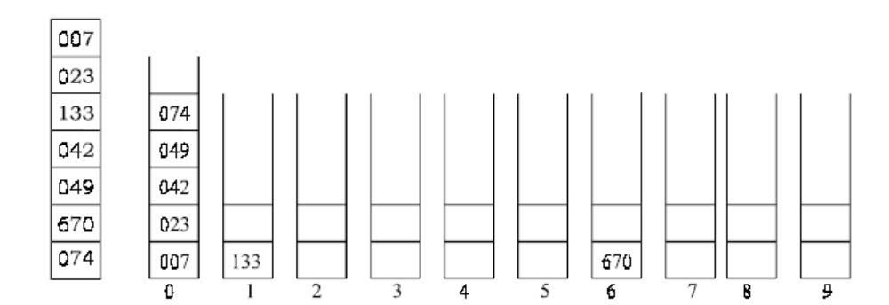

Read the element from the bucket from left to right and from bottom to top for the sorted array. i.e., 7 23, 42, 49, 74, 133, 670.

- ALGORITHM
Let A be a linear array of n elements A[1], A[2], A[3],...... A[n]. Digit is the total number of digits in the largest element in array A.

- Start
- Input n number of elements in an array A.
- Find the total number of Digits in the largest element in the array.
- Initialise i = 1 and repeat the steps 4 and 5 until (i <= Digit).
- Initialise the buckets j = 0 and repeat the steps (a) until ( j < n)
  - Compare i^{th} position of each element of the array with bucket number and
place it in the corresponding bucket.
- Read the element(s) of the bucket from 0th bucket to 9th bucket and from first position to higher one to generate new array A.
- Display the sorted array A.
- Stop.

